Spring Boot Case Study

Question 1:

Using Spring Boot Insert values in DB

ALGORITHM:

* Create the Post mapping Annotation for calling the API
* Use Request Body for get the input from the API
* Call the customer service class for insert the values in DB.

CODING :

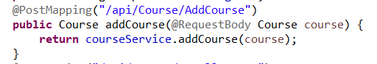

INPUT :

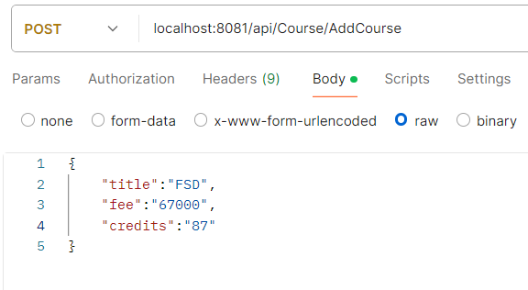

OUTPUT:

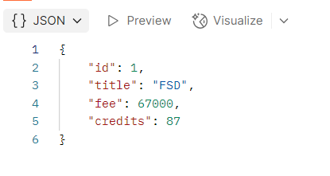

QUESTION 2:

Get All the courses from the DB

ALGORITHM:

* Declare the GET MAPPING annotation for print the details
* Store the values in the list for printing
* Call the Customer Service class for get the values

CODING :

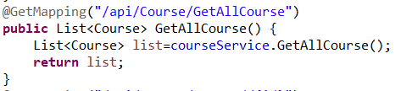

INPUT :

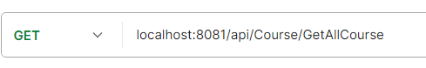

OUTPUT :

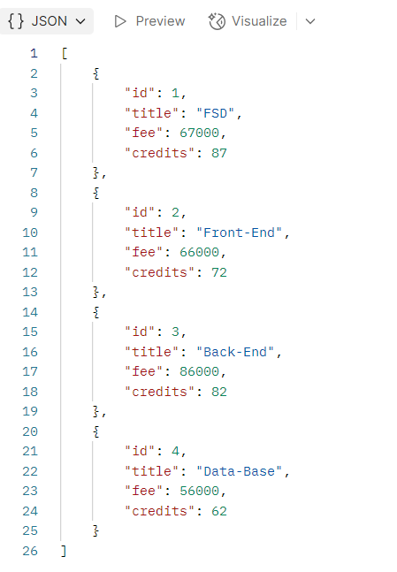

QUESTION 3:

Print the details by Course ID

ALGORITHM:

* Declare the GET MAPPING annotation for printing the details in API
* Using Path Variable we can get the course id from API
* Pass the course id to customer service we can fetch the details of the customer
* Here we are using Exception handling when the user insert a wrong course id.
* And we are printing the details in 400 Bad request format and the reason for error in the API.

CODING :

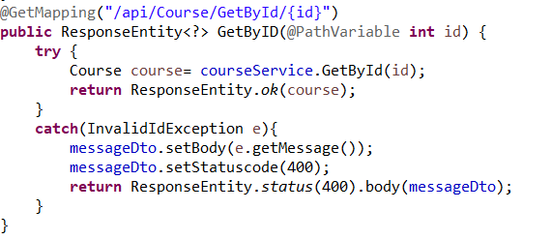

INPUT 1:

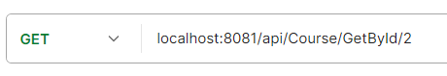

OUTPUT 1:

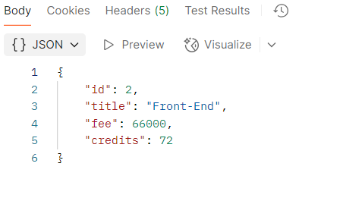

INPUT 2:



OUTPUT 2:

